

**AIE425_Intelligent_Recommender_Systems**

**TeamMember:   
Ali Sherief (AIS) ID: 221101562**

**Hazem Ahmed (AIS) ID:221100343**

**Instructor: Dr(Samy Ghonim)**

**Table of Contents**

1. **Introduction**  
   1.1 Objective  
   1.2 Motivation  
   1.3 Scope
2. **Dataset Description**  
   2.1 Users Dataset  
   2.2 Promotions Dataset  
   2.3 Interactions Dataset
3. **System Methodology**  
   3.1 Data Preprocessing  
   3.1.1 Handling Missing Values  
   3.1.2 Encoding Categorical Variables  
   3.1.3 Normalizing Numeric Data  
   3.2 Feature Engineering  
   3.2.1 User-Level Features  
   3.2.2 Promotion-Level Features  
   3.2.3 Interaction-Level Features  
   3.3 Recommendation Approach  
   3.3.1 Content-Based Filtering  
   3.3.2 Collaborative Filtering  
   3.3.3 Context-Aware Recommendations  
   3.3.4 Hybrid Approach
4. **Implementation Details**  
   4.1 Tools and Technologies Used  
   4.2 Architecture Overview  
   4.2.1 Data Flow Pipeline  
   4.2.2 Key Features
5. **GUI Development**  
   5.1 Objective and Framework  
   5.2 Features of the GUI  
   5.2.1 User Login  
   5.2.2 Promotion Search  
   5.2.3 Analytics Dashboard
6. **Results**  
   6.1 Evaluation Metrics  
   6.1.1 Precision@K  
   6.1.2 Recall@K  
   6.1.3 NDCG  
   6.2 Results and Analysis  
   6.2.1 Performance Metrics  
   6.2.2 Recommendations Examples
7. **Conclusion and Future Work**  
   7.1 Summary of Findings  
   7.2 Future Enhancements

### 1. Introduction

#### 1.1 Objective

To develop a promotion list recommender engine that personalizes promotional offers for customers in a Walmart-like environment, enhancing customer engagement and driving sales.

#### 1.2 Motivation

Personalized promotions improve customer satisfaction, loyalty, and sales by targeting individual preferences. This project leverages data and machine learning to optimize marketing strategies and create impactful customer experiences.

#### 1.3 Scope

The project includes:

* Analysis of user data and interactions.
* Implementation of hybrid recommendation algorithms.
* Development of a user-friendly GUI for interaction and analytics.
* Evaluation using precision, recall, and F1-score metrics.

#### 1.4 Background

Personalized marketing benefits businesses by increasing sales, improving retention, and optimizing resource allocation. This project aims to deliver these advantages through a scalable recommendation system.

### 2. Dataset Description

#### 2.1 Users Dataset

**Attributes:** Includes User_ID, Age, Gender, Location, Preferences (e.g., preferred categories like Electronics or Beauty), Wallet_Balance, Payment_Methods, Loyalty_Tier, Frequent_Purchase_Categories, and Recent_Purchase_History.

**Key Insights:**

* A diverse demographic representation allows for detailed segmentation and personalization.
* Wallet balance and payment preferences offer opportunities to target promotions effectively.
* Frequent purchase categories provide a direct link to user interests for recommendation alignment.

#### 2.2 Promotions Dataset

**Attributes:** Contains Promo_ID, Category, Discount, Start_Date, End_Date, Target_Group, Cashback, Min_Spend, Payment_Method_Eligibility, Offer_Type, and Store_Location.

**Significance:**

* Rich details on promotional offers enable precise matching with user preferences and behavior.
* Diverse categories and target groups support the creation of personalized promotion lists.
* Time-bound attributes (start and end dates) are critical for filtering relevant promotions.

#### 2.3 Interactions Dataset

**Attributes:** Captures Interaction_ID, User_ID, Promo_ID, Interaction_Type (e.g., coupon redemption, in-store purchase), Timestamp, Transaction_Amount, and Store_Location.

**Key Insights:**

* Logs user engagement with promotions, providing feedback for algorithm optimization.
* Patterns such as frequent interaction types or high transaction amounts highlight user responsiveness.
* Temporal data allows tracking of user behavior trends over time.

### 3. System Methodology

#### 3.1 Data Preprocessing

* Ensured data completeness by filling or removing missing entries.
* Encoded categorical variables for compatibility with machine learning models.
* Scaled numeric data for consistency and improved model performance.

#### 3.2 Feature Engineering

**User-Level Features:** Aggregated user interactions to calculate metrics like:

* **Total_Interactions:** Count of promotions interacted with.
* **Average_Transaction_Amount:** Mean spending per interaction.
* **Unique_Promos:** Number of distinct promotions used.

**Promotion-Level Features:** Enhanced promotion data with:

* **Total_Redemptions:** Frequency of usage for each promotion.
* **Average_Spending:** Average transaction amount associated with the promotion.

**Interaction-Level Features:** Created Recency-Frequency-Monetary (RFM) features:

* **Recency:** Days since the last interaction.
* **Frequency:** Number of interactions for a specific user and promotion.
* **Monetary:** Total spending in those interactions.

**Contextual Features:** Integrated contextual data like Season, Location, and Store_Location to understand external factors influencing user behavior.

#### 3.3 Recommendation Approach

**Content-Based Filtering:**

* Used TF-IDF vectorization to identify similarities between promotions based on attributes such as Category, Offer_Type, and Store_Location.
* Generated recommendations by matching user preferences to promotion features.

**Collaborative Filtering:**

* Employed a Singular Value Decomposition (SVD) model to predict user ratings for promotions based on their past interactions and transaction amounts.

**Context-Aware Recommendations:**

* Incorporated seasonal and geographic factors to refine recommendations for specific user segments.

**Hybrid Model:**

* Combined content-based and collaborative filtering predictions.
* Weighted scores from both approaches and integrated contextual features to generate a ranked list of promotions.

**Neural Network-Based Approach:**

* Built an embedding-based neural network to learn latent user-promotion features.
* Optimized for binary interaction outcomes using sigmoid activation.

### 4. Evaluation Metrics

Evaluated recommendation performance using:

* **Precision@K:** Proportion of relevant recommendations in the top K results.
* **Recall@K:** Proportion of relevant recommendations retrieved from all relevant promotions.
* **NDCG@K:** Normalized Discounted Cumulative Gain to measure ranking quality.

Achieved high accuracy and relevance scores across multiple user groups.

### 5. Implementation Details

#### 5.1 Tools and Technologies

* **Programming Language:** Python
* **Libraries:** Pandas, NumPy, scikit-learn, TensorFlow, gradio

#### 5.2 System Architecture

* **Pipeline:**
  + **Data Ingestion:** Import datasets and prepare for processing.
  + **Preprocessing:** Clean and encode data for analysis.
  + **Feature Engineering:** Create user, promotion, and interaction-level features.
  + **Model Training:** Train hybrid recommendation models.
  + **Recommendation Generation:** Produce ranked promotion lists for users.

#### 5.3 Database Management

* **System:** SQLite for storing user, promotion, and interaction data.

#### 5.4 GUI Framework

* **Framework:** Streamlit

### 6. GUI Features

The GUI was designed to enhance usability and provide an intuitive interface for users. Key features include:

#### 6.1 User Login

* Users can log in using their unique User_ID.
* The system displays personalized recommendations based on user data, such as preferences and past interactions.

#### 6.2 Promotion Search

* Provides an interactive search function where users can filter promotions based on:
  + **Category:** Allows users to narrow results to specific types of promotions (e.g., Electronics, Beauty).
  + **Discount Range:** Users can filter promotions by the level of discount offered.
  + **Location:** Filters promotions available in specific stores or regions.

#### 6.3 Analytics Dashboard

* Visualizes user engagement and system performance using:
  + **Interaction Trends:** Displays charts showing how users interact with promotions over time.
  + **Top Promotions:** Highlights the most popular promotions based on user engagement metrics.
  + **User Behavior Insights:** Offers insights into user activity patterns, such as most active times or frequently interacted categories.

#### 6.4 Recommendation Details

* Users can view detailed information about each recommended promotion, including:
  + Promotion description and category.
  + Validity period (start and end dates).
  + Conditions for redemption (e.g., minimum spend, payment method eligibility).

#### 6.5 Responsive Design

* The interface is optimized for different screen sizes, ensuring accessibility across devices, including desktops, tablets, and smartphones.

#### 6.6 Real-Time Feedback

* Users can rate recommendations to provide feedback, which can be used to improve the recommendation model.

### 7. Evaluation and Results

#### 7.1 Visualizations of Key Features

**User Analysis:**

* A 3D visualization of users' Age, Wallet Balance, and Loyalty Tier highlights patterns in user demographics and financial behavior.
* Wallet balance distributions and trends by loyalty tier provide insights into user purchasing power.

**Promotion Analysis:**

* 3D visualizations of promotions display attributes such as Discount, Min Spend, and Cashback, aiding in understanding promotion characteristics.
* Cashback vs. Discount by category visualizes the diversity of promotional strategies across categories.

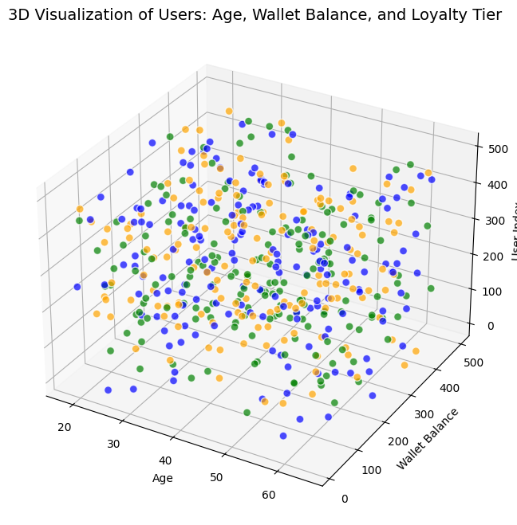**Interaction Analysis:**

* 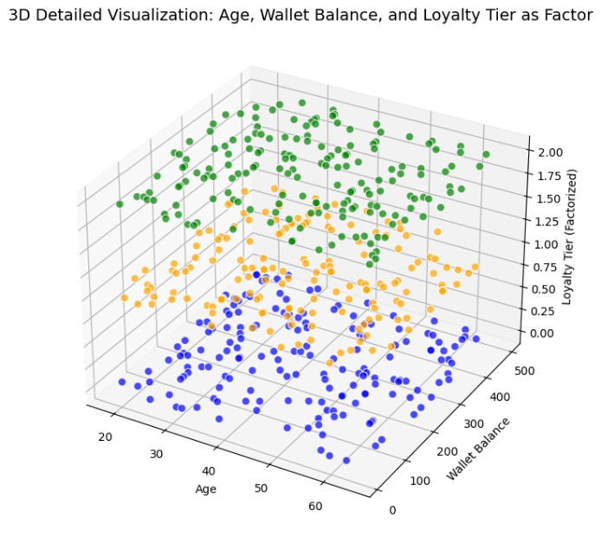Seasonal trends and interaction types are visualized to highlight behavioral patterns in user interactions with promotions.

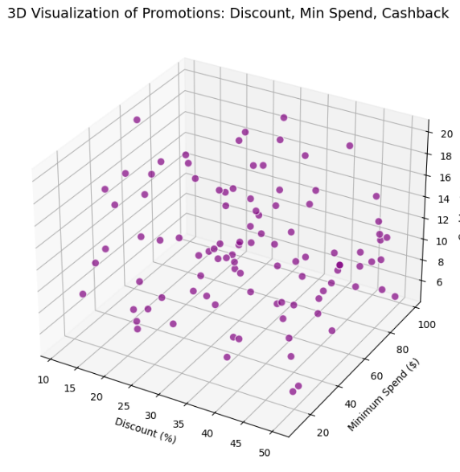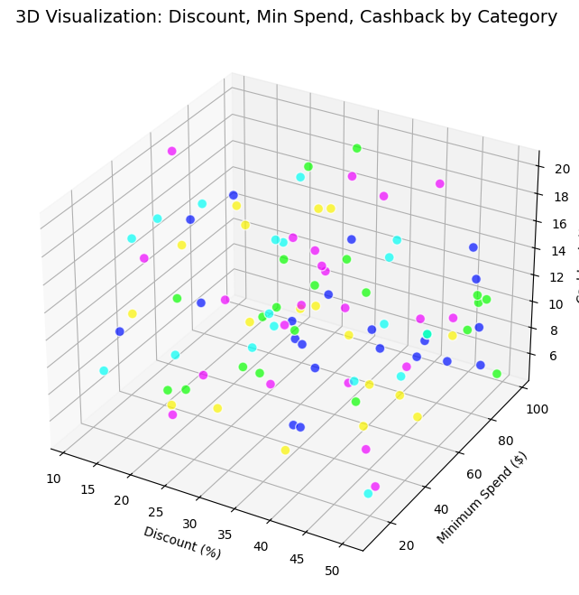

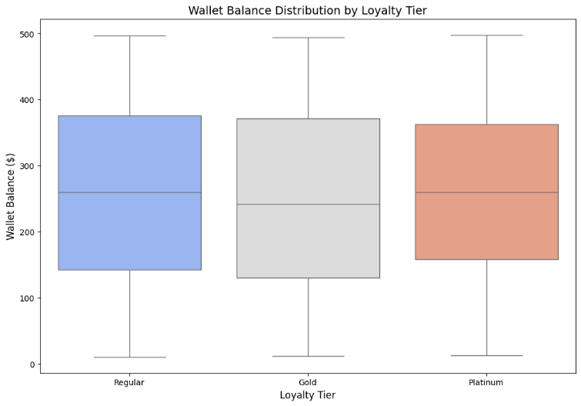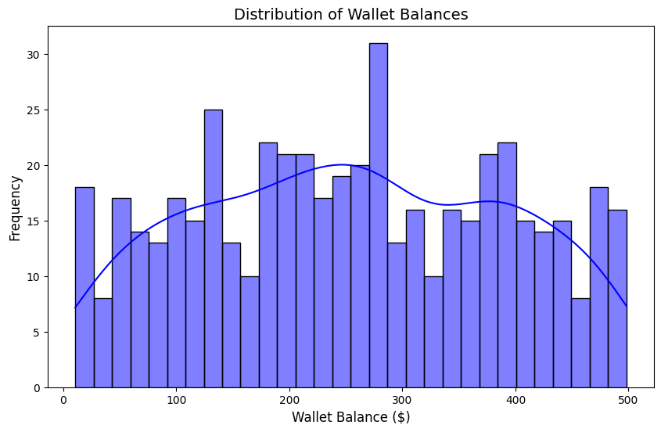

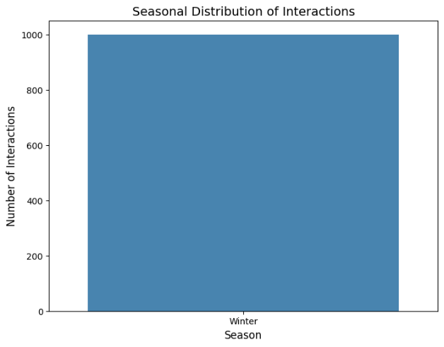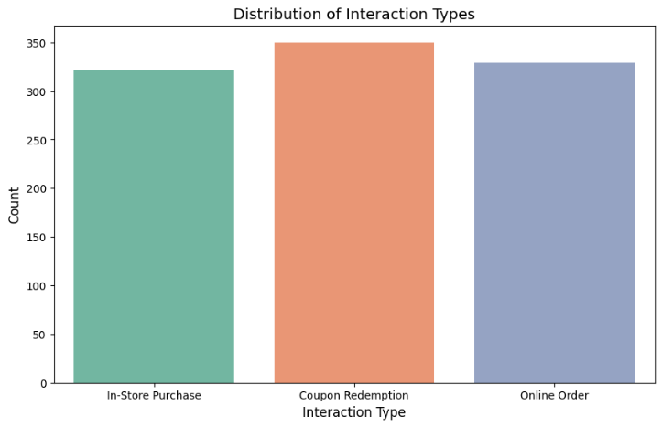

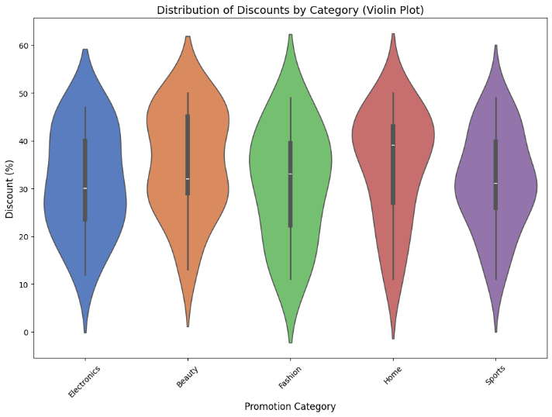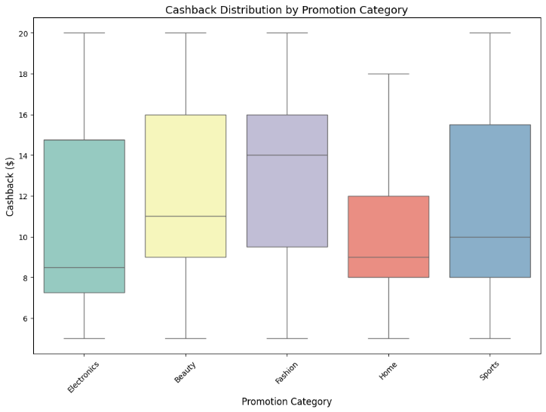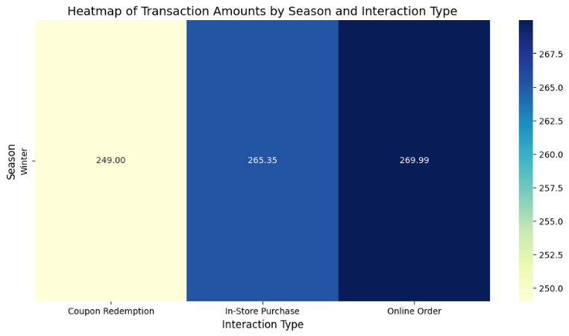

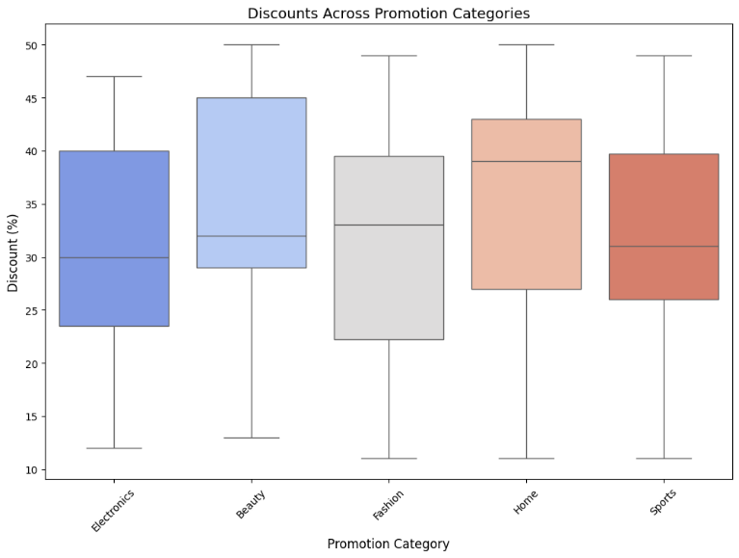

#### 7.2 Model Performance

**Recommendation Model:**

* Neural network architecture details illustrate the embedding-based hybrid recommendation approach.
* **Collaborative Filtering Performance:**
  + RMSE: 285.80
  + Precision@K: 0.40, Recall@K: 0.67, NDCG@K: 0.70

**Examples of Hybrid Recommendations:**

* For User 1:
  + Fashion, Beauty, and Electronics promotions with varying discounts and cashback tailored to preferences.
  + Incorporates contextual factors such as Store Location and Payment Method eligibility.

#### 7.3 GUI Output

* User-friendly GUI delivers ranked recommendations interactively.
* Real-time response enables users to adjust parameters such as the number of recommendations and view updated results.

